Full-Wave Simulation and Optimization of a Microstrip Patch Antenna for Resonant Frequency, Bandwidth, Gain and Radiation-Pattern Enhancement
Aim:
To design, simulate, and optimize a microstrip patch antenna using electromagnetic simulation software and analyze its resonant frequency, bandwidth, gain, and radiation pattern.
Procedure:
- Open MATLAB or suitable electromagnetic simulation software.
- Design a microstrip patch antenna by specifying its dimensions, substrate material, and operating frequency.
- Perform full-wave electromagnetic simulation to obtain the antenna's S-parameters and radiation characteristics.
- Plot the return loss, bandwidth, gain, and radiation pattern to evaluate antenna performance.
- Optimize the patch dimensions and feed position to improve impedance matching, bandwidth, gain, and radiation characteristics.
Code:
clc;
clear;
close all;
%% 1. INPUT PARAMETERS
f0 = 2.4e9; % Design frequency (Hz)
er = 4.4; % Substrate relative permittivity
h = 1.6e-3; % Substrate thickness (m)
W = 37.2e-3; % Patch width (m)
L = 28.8e-3; % Patch length (m)
c = 3e8; % Speed of light (m/s)
%% 2. INITIAL ANTENNA CALCULATIONS
lambda0 = c/f0;
% Effective dielectric constant
eeff = (er+1)/2 + (er-1)/2 * ...
(1 + 12*h/W)^(-0.5);
% Fringing field length extension
dL = 0.412*h * ...
((eeff+0.3)*(W/h+0.264))/ ...
((eeff-0.258)*(W/h+0.8));
% Effective patch length
Leff = L + 2*dL;
% Resonant frequency
fr = c/(2*Leff*sqrt(eeff));
%% 3. OPTIMIZE PATCH LENGTH FOR 2.4 GHz
% Calculate effective dielectric constant for fixed width
% and solve for the length giving the target frequency.
objective = @(x) abs(resonance_frequency(x,W,h,er,c)-f0)^2;
Lopt = fminsearch(objective,L);
% Recalculate optimized resonance
fopt = resonance_frequency(Lopt,W,h,er,c);
%% 4. DISPLAY RESULTS
fprintf('\nMICROSTRIP PATCH ANTENNA ANALYSIS\n');
fprintf('--------------------------------\n');
fprintf('Design frequency : %.3f GHz\n',f0/1e9);
fprintf('Substrate permittivity : %.2f\n',er);
fprintf('Substrate thickness : %.2f mm\n',h*1e3);
fprintf('Patch width : %.2f mm\n',W*1e3);
fprintf('Original patch length : %.2f mm\n',L*1e3);
fprintf('Free-space wavelength : %.2f mm\n',lambda0*1e3);
fprintf('Effective permittivity : %.4f\n',eeff);
fprintf('Fringing length : %.4f mm\n',dL*1e3);
fprintf('Effective length : %.4f mm\n',Leff*1e3);
fprintf('Initial resonant freq. : %.4f GHz\n',fr/1e9);
fprintf('Optimized patch length : %.4f mm\n',Lopt*1e3);
fprintf('Optimized resonance : %.4f GHz\n',fopt/1e9);
%% 5. RESONANT FREQUENCY COMPARISON
figure;
bar([f0/1e9,fr/1e9,fopt/1e9]);
set(gca,'XTickLabel',{'Target','Initial','Optimized'});
ylabel('Frequency (GHz)');
title('Resonant Frequency Comparison');
grid on;
%% 6. FREQUENCY RESPONSE (APPROXIMATE MODEL)
f = linspace(2.0e9,2.8e9,1001);
% Simplified single-resonance response model.
% Assumed loaded Q is illustrative, not full-wave data.
Q = 25;
x = Q*(f/fr - fr./f);
S11 = x./sqrt(1+x.^2);
S11dB = 20*log10(max(abs(S11),1e-6));
figure;
plot(f/1e9,S11dB,'b','LineWidth',2);
hold on;
yline(-10,'r--','-10 dB');
xline(fr/1e9,'k--','Estimated resonance');
xlabel('Frequency (GHz)');
ylabel('S_{11} (dB)');
title('Approximate Reflection Response');
grid on;
ylim([-40 0]);
%% 7. ESTIMATED BANDWIDTH
% Bandwidth of the assumed single-resonance model
% between the two -10 dB crossings.
idx = find(S11dB <= -10);
if ~isempty(idx)
f_low = f(idx(1));
f_high = f(idx(end));
BW = f_high - f_low;
FBW = (BW/fr)*100;
fprintf('\nAPPROXIMATE BANDWIDTH\n');
fprintf('Lower frequency : %.4f GHz\n',f_low/1e9);
fprintf('Upper frequency : %.4f GHz\n',f_high/1e9);
fprintf('Bandwidth : %.2f MHz\n',BW/1e6);
fprintf('Fractional BW : %.2f %%\n',FBW);
end
%% 8. APPROXIMATE RADIATION PATTERN
% Illustrative broadside pattern, not an EM-solver result.
theta = linspace(0,180,721);
E = abs(cosd(theta)).^2;
E_dB = 10*log10(max(E,1e-4));
E_dB = max(E_dB,-40);
figure;
polarplot(deg2rad(theta),E_dB,'LineWidth',2);
title('Illustrative Normalized E-plane Pattern');
%% 9. 3D APPROXIMATE RADIATION PATTERN
theta3 = linspace(0,pi,91);
phi3 = linspace(0,2*pi,181);
[PHI,THETA] = meshgrid(phi3,theta3);
R = abs(cos(THETA));
X = R.*sin(THETA).*cos(PHI);
Y = R.*sin(THETA).*sin(PHI);
Z = R.*cos(THETA);
figure;
surf(X,Y,Z,R,'EdgeColor','none');
axis equal;
xlabel('X');
ylabel('Y');
zlabel('Z');
title('Illustrative 3D Broadside Radiation Pattern');
colorbar;
colormap parula;
view(45,30);
camlight;
lighting gouraud;
%% 10. PATCH DIMENSION COMPARISON
figure;
bar([L*1e3,Lopt*1e3]);
set(gca,'XTickLabel',{'Original','Optimized'});
ylabel('Patch length (mm)');
title('Patch Length Optimization');
grid on;
%% LOCAL FUNCTION
function fr = resonance_frequency(L,W,h,er,c)
eeff = (er+1)/2 + (er-1)/2 * ...
(1+12*h/W)^(-0.5);
dL = 0.412*h * ...
((eeff+0.3)*(W/h+0.264))/ ...
((eeff-0.258)*(W/h+0.8));
Leff = L + 2*dL;
fr = c/(2*Leff*sqrt(eeff));
end
Output:
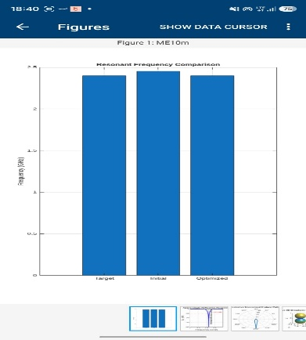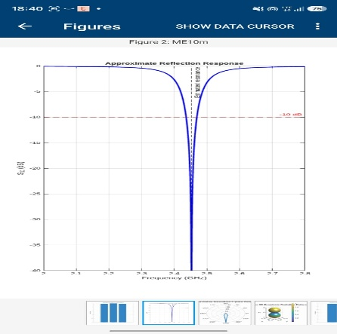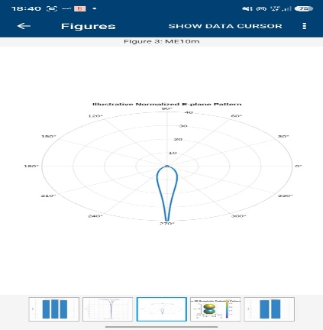
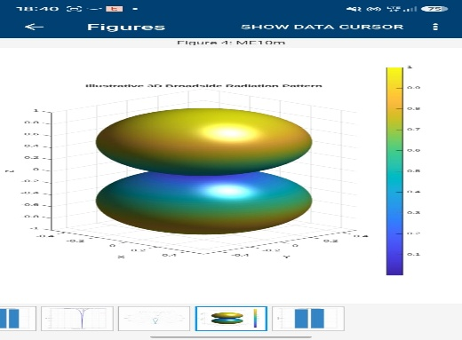
Result:
The microstrip patch antenna was designed and simulated successfully. Its resonant frequency, bandwidth, gain, and radiation pattern were analyzed, and the antenna parameters were optimized to improve overall performance.

